HT-006 — Publishing Pop Off to the Google Play Store
Doc ID: HT-006  Type: How-To  Version: 1.0 | Author: Ozzy (Claude — Atlantis AI)  Status: Draft  Date: March 2026

Overview
This guide covers the complete process of publishing Pop Off (Expo / React Native) to the Google Play Store for the first time — from zero. It covers creating the Google Play Developer account, configuring EAS Build, generating the production AAB, manually uploading the first build (required by Google), completing all Play Console requirements, and submitting for production review.

Pop Off details:
- App: Pop Off — Slightly savage. Always funny.
- Framework: Expo (React Native)
- Build tool: EAS (Expo Application Services)
- Target: Android (Google Play Store) — Apple App Store is a separate guide (HT-007)
- Working directory: D:\Data\AtlantisITS\projects\popoff-app
- expo-doctor status: 17/17 checks passed ✅ — March 2026

💰 Total one-time cost: $25 USD — Google Play Developer account registration fee. This is a one-time payment, not a subscription. It covers all apps you publish under the same account forever.

Pre-Flight Checklist
Confirm all of these before starting:

Item | Status
expo-doctor — 17/17 checks passed | ✅ Confirmed March 2026
Expo account created at expo.dev | Confirm before Step 2
EAS CLI installed globally | Confirm in Step 2
Google account ready (Srhardin@gmail.com) | Use for Play Console
$25 USD payment method available | Required for Step 1
App icon — 512x512 PNG | Required for Play Console listing
Feature graphic — 1024x500 PNG | Required for Play Console listing
At least 2 screenshots (phone) | Required for Play Console listing
Privacy policy URL | Required — even for free apps
Short description — max 80 chars | Prepare before starting
Full description — max 4000 chars | Prepare before starting

💡 Prepare your store listing assets (icon, screenshots, descriptions) BEFORE starting the Play Console setup. Google will not let you proceed to production without them. Having them ready saves significant time.

Phase 1 — Google Play Developer Account

Step 1 — Create Google Play Developer Account
- Go to: https://play.google.com/console/signup
- Sign in with Srhardin@gmail.com
- Choose account type: Individual (not Organization — no business verification required)
- Fill in developer name — this is what users see on the Play Store
- Pay the $25 USD one-time registration fee
- Complete identity verification — Google requires a government-issued ID and proof of address for individual accounts. This is standard and typically clears within 24-48 hours.
- Once verified, you land on the Google Play Console dashboard

⚠️ Individual developer accounts show your home address publicly on the Play Store if you ever publish paid apps. For free apps with no in-app purchases, this is not displayed. Pop Off is free tier + Pro (IAP) — confirm address display rules before adding billing.

📸 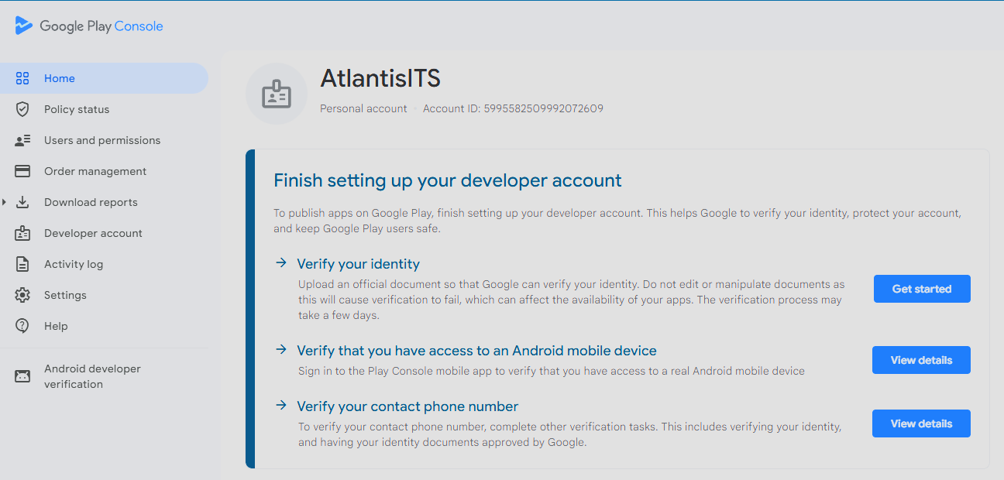

Phase 2 — EAS Setup & Production Build

Step 2 — Install EAS CLI and Log In
# Install EAS CLI globally
npm install -g eas-cli

# Verify installation
eas --version

# Log in to your Expo account
eas login
# Enter your Expo account email and password
# Confirm with: eas whoami

💡 If you don't have an Expo account yet, create one free at https://expo.dev/signup before running eas login. EAS Build is free for personal use with generous build limits.

Step 3 — Configure EAS in the Pop Off Project
# Navigate to Pop Off project
cd D:\Data\AtlantisITS\projects\popoff-app

# Initialize EAS in the project (if not already done)
eas init
# This links your local project to your Expo account
# Accept prompts — it creates/updates app.json with your Expo project ID

Verify your eas.json has a production build profile. If eas.json does not exist, create it:

# Check if eas.json exists
ls eas.json

# If it doesn't exist, run:
eas build:configure
# Select: Android
# This generates eas.json with default profiles

Your eas.json should contain at minimum:

{
"cli": {
"version": ">= 5.0.0"
},
"build": {
"production": {
"android": {
"buildType": "app-bundle"
}
}
},
"submit": {
"production": {
"android": {
"track": "internal"
}
}
}
}

💡 buildType: app-bundle produces an .aab file (Android App Bundle) — required for Play Store submission. The AAB format is smaller than APK and is the only format Google accepts for new apps.

Step 4 — Verify app.json Configuration
Open app.json and confirm these fields are set correctly for Pop Off:

{
"expo": {
"name": "Pop Off",
"slug": "popoff-app",
"version": "1.0.0",
"android": {
"package": "com.atlantisits.popoff",
"versionCode": 1
},
"icon": "./assets/icon.png",
"splash": { ... }
}
}

⚠️ The android.package value (com.atlantisits.popoff) is permanent — once you publish to the Play Store it cannot be changed. Ever. Choose it carefully before your first build.

Step 5 — Create Production Build
# From the popoff-app directory
cd D:\Data\AtlantisITS\projects\popoff-app

# Trigger production build (uploads to EAS cloud build servers)
eas build --platform android --profile production

# EAS will ask: Generate a new Android Keystore?
# Select: Yes — Generate new keystore
# EAS stores the keystore securely on their servers

# Build typically takes 5-15 minutes
# You will get a URL to monitor build progress
# You can close the terminal — build continues in the cloud

⚠️ CRITICAL: Let EAS generate and manage the keystore for you. Do NOT manage your own keystore manually. If you ever lose a self-managed keystore you will be permanently unable to publish updates to Pop Off. EAS keystore management is the safe option.

When complete, the build dashboard shows a Download button for the .aab file. Note the build URL — you will need it in Step 7.

📸 SCREENSHOT PLACEHOLDER — EAS Build dashboard — Pop Off production build complete, .aab download available

Phase 3 — Play Console Setup

💡 This phase has the most manual steps. Google's Play Console is a checklist-driven dashboard — every item must be green before you can submit for production. Work through them systematically.

Step 6 — Create the App in Play Console
- Go to: https://play.google.com/console
- Click: Create app

Field | Value for Pop Off
App name | Pop Off
Default language | English (United States)
App or game | App
Free or paid | Free

- Click: Create app
- You are now on the Pop Off dashboard in Play Console
- Click: View tasks under Start testing now — this opens your to-do checklist

📸 SCREENSHOT PLACEHOLDER — Play Console — Pop Off app dashboard showing task checklist

Step 7 — First Manual Upload (Required by Google)
Google requires the first build to be uploaded manually through the Play Console UI. After this, EAS Submit can automate all future submissions. This is a Google API limitation — there is no workaround.

- In EAS Build dashboard — click Download on your production build to save the .aab file
- In Play Console — go to: Testing → Internal testing → Create new release
- Under App bundles — click Upload and select the .aab file you downloaded
- For signing key — select: Use Google-generated key (recommended — safer than self-managed)
- Add release notes (optional for internal testing)
- Click: Save → Review release → Start rollout to Internal testing

✅ First build is now uploaded. From this point forward you can use eas submit -p android to automate all future uploads without opening Play Console.

📸 SCREENSHOT PLACEHOLDER — Play Console — Internal testing release showing Pop Off .aab uploaded successfully

Step 8 — Add Internal Testers
- In Play Console — go to: Testing → Internal testing → Testers tab
- Create an email list — name it: Atlantis Internal
- Add your email: Srhardin@gmail.com
- Add Maranda's email if she will test on her device
- Click: Save changes
- Click: Copy link — share with testers so they can install the app

💡 You need at least one tester (yourself) and the app must be tested for 14 days before applying for production access on an individual developer account. Plan your timeline accordingly — submit internal testing at least 2 weeks before your production target date.

Phase 4 — Complete Play Console Requirements
Work through all checklist items on the Play Console dashboard. All must be green before production submission. The main sections:

Step 9 — App Content & Store Listing

9.1 Privacy Policy
- Go to: Policy → App content → Privacy policy
- Enter your privacy policy URL — this is required even for free apps
- If you don't have one, generate a free one at: https://www.privacypolicygenerator.info
- Must be hosted at a public URL — Vercel or GitHub Pages works fine

9.2 App Access
- Go to: Policy → App content → App access
- Select: All or most functionality is accessible without special access

9.3 Content Rating
- Go to: Policy → App content → Content rating
- Click: Start questionnaire
- Category: Entertainment
- Answer questions about content — Pop Off contains humor/roast content, flag appropriately
- Submit — Google assigns a rating (likely Everyone 10+ or Teen based on content)

9.4 Target Audience
- Go to: Policy → App content → Target audience and content
- Select target age group — Pop Off targets teens, select: Ages 13-17 and 18+
- Confirm the app does not target children under 13

9.5 Main Store Listing
- Go to: Grow → Store presence → Main store listing

Asset | Specification
App name | Pop Off (max 30 chars)
Short description | Slightly savage. Always funny. (max 80 chars)
Full description | Full app description (max 4000 chars)
App icon | 512 x 512 PNG — no alpha/transparency
Feature graphic | 1024 x 500 PNG or JPG
Phone screenshots | Minimum 2, maximum 8 — 16:9 or 9:16 ratio

⚠️ Store listing assets are required before production submission. Screenshots must be taken from an actual device or high-fidelity emulator — no mockups with device frames that misrepresent the UI.

Phase 5 — Production Submission

Step 10 — Promote from Internal to Production
- In Play Console — confirm all dashboard checklist items are green
- Go to: Testing → Internal testing → your release → Promote release → Production
- Review the production release details
- Set rollout percentage — start at 20% for a staged rollout (safer for first release)
- Click: Start rollout to Production → Send for review

Review timeline | Typical duration
First-time app review | 1–7 days (Google reviews new apps more thoroughly)
Subsequent updates | Hours to 1-2 days
Review outcome | Approved / Rejected with reason / Policy violation

💡 During review, your app status shows as In review in the Play Console. You will receive an email when the review is complete. Do not submit multiple builds during an active review — wait for the outcome first.

📸 SCREENSHOT PLACEHOLDER — Play Console — Pop Off production release showing In review status

Step 11 — Automate Future Submissions with EAS Submit
After the first manual upload (Step 7), set up EAS Submit for all future builds so you never have to manually upload again.

11.1 Create Google Service Account Key
- Go to: https://console.cloud.google.com
- Select your project → IAM & Admin → Service Accounts → Create Service Account
- Name: eas-submit-popoff → Click Done
- Click the service account → Keys tab → Add Key → JSON → Create
- Save the downloaded JSON file to: D:\Data\AtlantisITS\projects\popoff-app\service-account.json
- Add service-account.json to .gitignore immediately — never commit this file

11.2 Grant Play Console Permissions
- In Play Console → Users and permissions → Invite new user
- Enter the service account email address (from the JSON file)
- Grant permissions: Edit and delete draft apps + everything under Releases + Manage Store Presence
- Click: Apply → Invite user

11.3 Upload Key to EAS
# Upload service account key to EAS
eas credentials
# Select: Android
# Select: your app identifier
# Select: Google Service Account Key
# Select: Upload new key
# Provide path: D:\Data\AtlantisITS\projects\popoff-app\service-account.json

11.4 Future Builds — One Command Deploy
# For all future Pop Off Android releases:
cd D:\Data\AtlantisITS\projects\popoff-app

# Build AND submit in one command
eas build --platform android --profile production --auto-submit

# Or submit an existing build manually:
eas submit --platform android

✅ EAS Submit is now configured. All future Pop Off Android releases are a single command. No more manual Play Console uploads.

Troubleshooting
Issue | Cause | Fix
Build fails — keystore error | Keystore not generated yet | Run eas build again, select Generate new keystore
App rejected — policy violation | Content rating mismatch | Review content rating questionnaire answers, resubmit
App rejected — missing privacy policy | No privacy policy URL | Host a policy page and add URL to App content
Play Console upload fails | Wrong file type | Must be .aab not .apk for Play Store
eas submit fails — no service account | Service account not configured | Complete Step 11 — Google Service Account setup
Version code conflict | versionCode not incremented | Increment android.versionCode in app.json before next build
App not visible after approval | Staged rollout at <100% | Increase rollout percentage in Play Console
Identity verification stuck | Google processing delay | Normal — wait 24-48 hours, check email for updates
Screenshots rejected | Wrong dimensions | Use exactly 320-3840px on longest side, 16:9 or 9:16 ratio

Quick Reference
Item | Value
App package name | com.atlantisits.popoff
Working directory | D:\Data\AtlantisITS\projects\popoff-app
Play Console | https://play.google.com/console
EAS Dashboard | https://expo.dev/accounts/[your-username]/projects/popoff-app
Expo account | https://expo.dev
One-time fee | $25 USD — Google Play Developer account
Build command | eas build --platform android --profile production
Submit command | eas submit --platform android
Build + Submit | eas build --platform android --auto-submit
Check login | eas whoami
View builds | eas build:list
App icon size | 512 x 512 PNG
Feature graphic size | 1024 x 500 PNG or JPG
Min screenshots | 2 phone screenshots
Review time (first) | 1–7 days
Review time (updates) | Hours to 2 days

Next Steps After Approval
Task | Details
Monitor reviews and ratings | Play Console → Grow → Ratings and reviews
Set up crash reporting | Expo Sentry or Crashlytics integration
Track installs and retention | Play Console → Statistics dashboard
Publish first update | eas build --platform android --auto-submit (versionCode +1)
Apple App Store (iOS) | See HT-007 — Publishing Pop Off to the Apple App Store
Add in-app purchases (Pro tier) | Play Console → Monetize → Products → Subscriptions

